# Answers to Questions from TT 7.2.1

Name: Jayden Kong

Student ID: 104547242

**Hand execution using a trace table**

*Demonstrate how the following code is executed in the computer.*

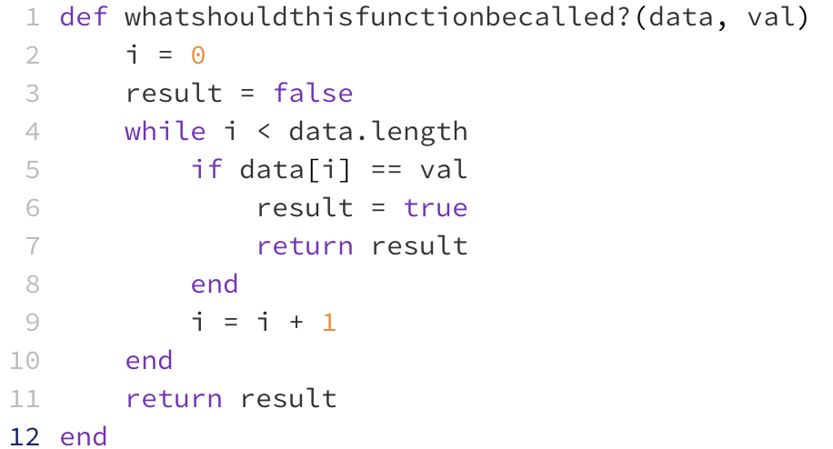

Draw and complete trace tables for the following two sets of data and place the final result in the table below:



**Once you have completed your trace tables (below) write the name you chose for the function above:**

is_value_in_data_set

**Place your trace tables below:**

For data set: **data** = [2, 6, -4, 3, 7] **val** = 3

|  |  |  |  |
| --- | --- | --- | --- |
| data[i] | i | val | result |
| 2 | 0 | 3 | false |
| 6 | 1 | 3 | false |
| -4 | 2 | 3 | false |
| 3 | 3 | 3 | true |

For data set: **data** = [-2, 8, 2, -5, 9] **val** = 6

|  |  |  |  |
| --- | --- | --- | --- |
| data[i] | i | val | result |
| -2 | 0 | 6 | false |
| 8 | 1 | 6 | false |
| 2 | 2 | 6 | false |
| -5 | 3 | 6 | false |
| 9 | 4 | 6 | false |

4. Suggestion for improvement of the code:

Instead of just returning true or false, the function could instead return the index of the element in the array that is equal to val (more information is provided). This can be done by defining another variable as being equal to i within the if statement in the while loop and returning this value. This variable could have a default value of -1 defined before the while statement in which will be returned if val is not found within the data set (essentially returns false).